

**No camping beyond**

**this point**

**Pavilion**

**23**

**20**

**21**

**24**

**25**

**19**

.

**East Rangely Ave.**

z

**Sites with Electricity**

**Sites without Electricity**

**Potable Water Spigot**

**Pay Station**

**2**

**18**

**16**

**51**

**15**

**Camp**

**Host**

**4**

**17**

**1**

**Rangely Camper Park**

**Women’s**

**Restroom**

**& Shower**

**3**

**Men’s**

**Restroom**

**& Shower**

**Women’s**

**Restroom**

**& Showers**

**6**

**Sanitation**

**Dump**

**7**

**N**

**Camper Park GPS Location**

**40° 5’18.96’’ N**

**108°47’22.08’’ W**

**E**

**W**

**8**

**14**

**10** **11**

**S**

**12**

**13**

**9**

**Like us on Facebook**

https://www.facebook.com/RangelyCamperPark

**Or find us at**

https://westernrioblancomrpd.colorado.gov

**Camper**

**Park**

**Access**

**Road**

**Rock Park**

**&**

**Waterfall**

**East Main Street**

**Rangely, CO**

**Highway 64**

**To**

**Meeker, CO**

**Rates:**

* Space with electricity $30.00

(30 Amp Hook Ups)

* Space without electricity $20.00
* Dump fee for non-camper $10.00
* Shower for non-camper $5.00
* Season dump pass $40.00

**Things to do:**

* Fish at the ponds NE of the Camper Park or in the White River. The White River is located a short distance north of the Park.
* Enjoy a drive to explore the petroglyphs around Rangely.
* Go boating and fishing at Kenney Reservoir. (5 miles east)
* Play a round of golf at Cedar Ridges Golf Course. A challenging 9-hole, 36-par golf course. (2 miles east)
* Swim and exercise at the WRB Recreation Center. (Located in town)

**Camper Park rules and regulations:**

* There is a 14-day stay limit.
* Camping fees are to be deposited in the envelopes provided at the entrance upon arrival. The space receipt is to be hung on the space post. Then put the remainder of the envelope in a deposit box found at either the Camper Park entrance or dump station.
* Paid camper fees include showers and sanitation dump.
* The speed limit in the camper park is 5 mph. This includes motorcycles and off-road vehicles.
* Animals must be confined to their own campsite and be picked up after.
* Do not leave a fire unattended. Burn combustibles only- no cans, glass, foil, or garbage. Fires must be out when leaving your site or retiring for the evening.
* 10:00 p.m. is when we ask guests to get quiet. We do not want to disturb campers trying to sleep.

Rangely Camper Park

611 S. Stanolind Ave

Rangely, CO 81648

* Intoxication, profanity, vandalism, or disorderly behavior will not be tolerated. Alcohol is not permitted off your site.
* Management is not responsible for damage, injury, or loss by accident, fire, or theft to either property or person. You enter and stay on the property at your own risk.

PLACE STAMP HERE

****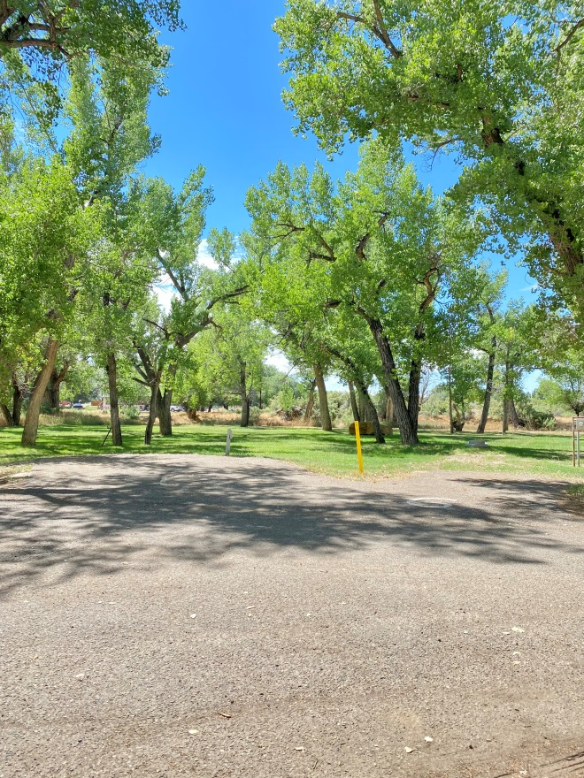

**Rangely Camper Park**

**940 East Rangely Ave**

**Rangely, CO 81648**

**(970) 675-8211**

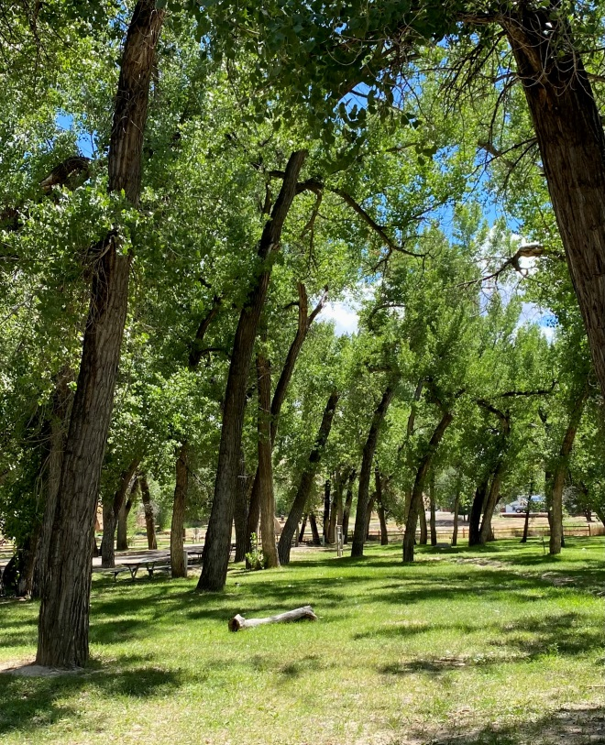Rangely Camper Park is operated by the WRB Rec and Park District. We hope that this brochure will answer some of the more common questions. If not, please give us a call. We are committed to do what we can to make your time with us as enjoyable as possible.